LAPORAN KEGIATAN

PRAKTEK KERJA INDUSTRI

DI.................................................................

KABUPATEN ACEH TAMIANG



DISUSUN OLEH :

Nama :

Nisn :

Program Keahlian : Teknik Komputer Informatika

Kompetensi Keahlian : Rekayasa Perangkat Lunak

PEMERINTAHAN ACEH

DINAS PENDIDIKAN

SEKOLAHMENENGAHKEJURUAN (SMK) NEGERI 1 KARANG BARU

KABUPATEN ACEH TAMIANG

# 

# LEMBAR PENGESAHAN

# LAPORAN KEGIATAN

# PRAKTEK KERJA INDUSTRI

# DI ...........................................................

# KABUPATEN ACEH TAMIANG

# Tahun 2023

Nama :

Nisn :

Program Keahlian : Teknik Komputer Infomatika

Kompetensi Keahlian : Rekayasa Perangkat Lunak

Telah disahkan tanggal, ..............................................

Menyetujui:

Pembimbing Industri / Instansi Pembimbing Sekolah

( ...................................................) ( ...................................)

Mengetahui :

Pimpinan Kepala ................................... Kepala SMKN 1 Karang Baru

( ...............................................) Fahmi Putra, S.Pd

NIP . 1979108200904 1 001

KATA PENGANTAR

DAFTAR ISI

# LEMBAR PENGESAHAN ...................................................................................i

# KATA PENGANTAR ..........................................................................................ii

# DAFTAR ISI.........................................................................................................iii

# BAB I PENDAHULUAN......................................................................................1

## 1.1. Latar Belakang.......................................................................................1

## 1.2. Tujuan.....................................................................................................1

## 1.3. Manfaat...................................................................................................1

## 1.4. Waktu dan Tempat Pelaksanaan..........................................................1

# BAB II PROFIL PERUSAHAAN........................................................................2

## 2.1. Sejarah Singkat......................................................................................2

## 2.2. Visi dan Misi...........................................................................................2

## 2.3. Struktur Organisasi...............................................................................2

## 2.4. Deskripsi Tugas Perusahaan................................................................2

# BAB III URAIAN KEGIATAN...........................................................................3

## 3.1. Rencana Kerja.....................................................................................3

## 3.2. Jurnal Kegiatan...................................................................................3

# BAB IV PENUTUP...............................................................................................4

## 4.1. Kesimpulan..........................................................................................4

## 4.2. Saran.....................................................................................................4

# DAFTAR PUSAKA................................................................................................5

LAMPIRAN............................................................................................................6

# DAFTAR GAMBAR

login 1

dashboard 1

# BAB I

# Pendahuluan

1.1. Latar Belakang

1.2. Tujuan

1.3. Manfaat

1.4. Waktu dan Tempat Pelaksanaan

# BAB II

# PROFIL PERUSAHAAN

2.1. Sejarah Singkat

2.2. Visi dan Misi

2.3. Struktur Organisasi

2.4. Deskripsi Tugas Perusahaan

# BAB III

# URAIAN KEGIATAN

3.1. Rencana Kerja

3.2. Jurnal Kegiatan

|  |  |  |  |  |  |  |  |  |  |  |  |  |  |  |  |  |  |  |  |  |  |  |  |  |  |  |
| --- | --- | --- | --- | --- | --- | --- | --- | --- | --- | --- | --- | --- | --- | --- | --- | --- | --- | --- | --- | --- | --- | --- | --- | --- | --- | --- |
| No | Uraian Kegiatan | Tempat | Bulan | | | | | | | | | | | | | | | | | | | | | | | |
| Agustus | | | | | September | | | | Oktober | | | | | November | | | | | Desember | | | | |
| 1 | 2 | 3 | 4 | 5 | 1 | 2 | 3 | 4 | 1 | 2 | 3 | 4 | 5 | 1 | 2 | 3 | 4 | 5 | 1 | 2 | 3 | 4 | 5 |
| 1 | Persiapan | Sekolah |  |  |  |  |  |  |  |  |  |  |  |  |  |  |  |  |  |  |  |  |  |  |  |  |
| 2 | Pengantaran | Sekolah |  |  |  |  |  |  |  |  |  |  |  |  |  |  |  |  |  |  |  |  |  |  |  |  |
| 3 | Perkenalan/Adaptasi | Tempat PKL |  |  |  |  |  |  |  |  |  |  |  |  |  |  |  |  |  |  |  |  |  |  |  |  |
| 4 | Analisis masalah | Tempat PKL |  |  |  |  |  |  |  |  |  |  |  |  |  |  |  |  |  |  |  |  |  |  |  |  |
| 5 | Merancang database | Tempat PKL |  |  |  |  |  |  |  |  |  |  |  |  |  |  |  |  |  |  |  |  |  |  |  |  |
| 6 | Merancang UX/UI | Tempat PKL |  |  |  |  |  |  |  |  |  |  |  |  |  |  |  |  |  |  |  |  |  |  |  |  |
| 7 | Mengetik source code | Tempat PKL |  |  |  |  |  |  |  |  |  |  |  |  |  |  |  |  |  |  |  |  |  |  |  |  |
| 8 | Uji coba aplikasi/debugging | Tempat PKL |  |  |  |  |  |  |  |  |  |  |  |  |  |  |  |  |  |  |  |  |  |  |  |  |
| 9 | Evaluasi | Tempat PKL |  |  |  |  |  |  |  |  |  |  |  |  |  |  |  |  |  |  |  |  |  |  |  |  |
| 10 | Kegiatan Rutin Harian Kantor | Tempat PKL |  |  |  |  |  |  |  |  |  |  |  |  |  |  |  |  |  |  |  |  |  |  |  |  |
| 11 | Penjemputan | Tempat PKL |  |  |  |  |  |  |  |  |  |  |  |  |  |  |  |  |  |  |  |  |  |  |  |  |

# BAB IV

# PENUTUP

4.1. Kesimpulan

4.2. Saran

# DAFTAR PUSAKA

# LAMPIRAN

|  |  |  |  |  |
| --- | --- | --- | --- | --- |
| NO | URAIAN | HARGA | JUMLAH | |
| RATAAN | TOTAL |
|  |  |  |  |  |
|  |  |  |
|  |  |  |  |  |
|  |  |  |  |  |
|  |  |  |  |  |
|  |  |  |  |  |
|  |  |  |  |  |
|  |  |  |  |  |

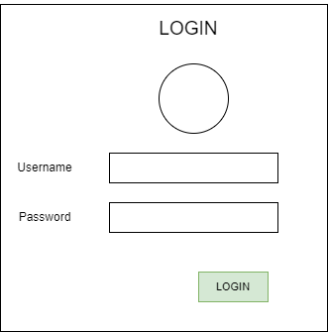

login 1

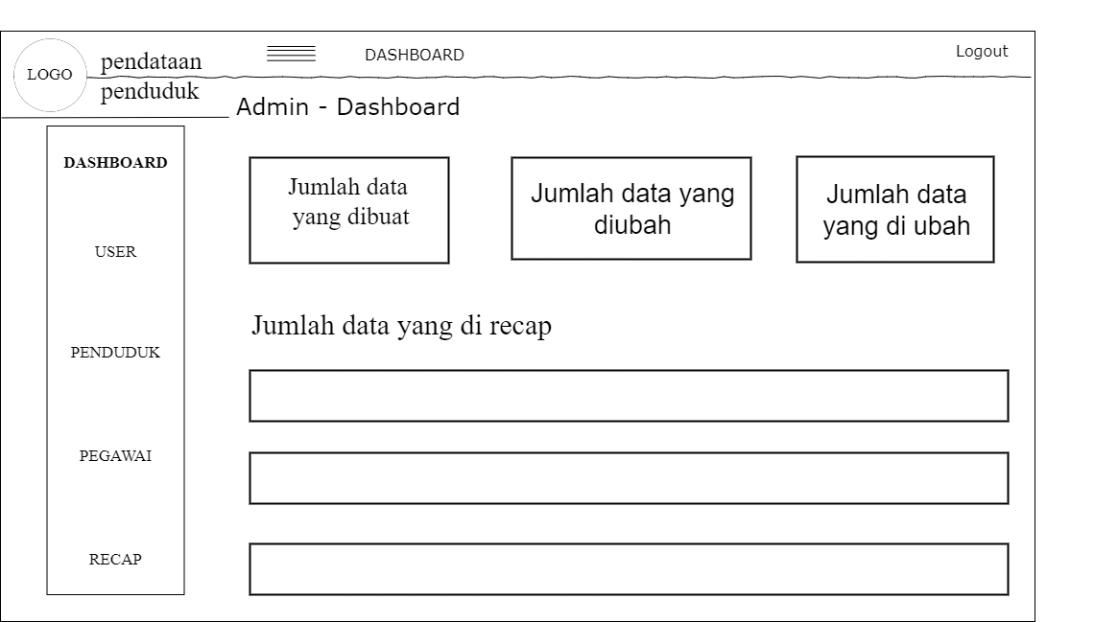

dashboard 1